# Fuxian Lake

In beautiful Yunnan, there is a clear lake called Fuxian Lake, which is the largest deep-water freshwater lake in China. It shines like a pearl, with clear water surrounding the mountains, with clouds rolling and clouds dispersing, every frame is like a painting…



(一个视频，抚仙湖概览）

* One on one personalized course
* Immersive experiences of scenery, history and local life
* Excellent tutors with professional certificates and rich teaching experience
* 3 meals Monday to Friday and accommodation

**One on one personalized course**

Course type available：

🗹 one on one intensive course for all language level/goals and culture demand

🗹 one on one Travel Chinese

🗹 one on one HSK preparation

We will **tailor your course** to your personal demand and language level, match you with the tutor who is most suitable for you as well.

Classes are held from every Monday to Friday. You can choose to study **4 hours, 5 hours or 6 hours** per day. The daily class schedule is very **flexible** and can be adjusted according to your dynamic requirements.

Your tutor will not only help you achieve your learning goals, but also create rich **real-world** contexts for you and accompany you to **practice** in all-Chinese speaking environment, truly **combining learning with application** and naturally **integrating into the local life**.

**Immersive experiences of scenery, history and local life**

Get up close with nature in the Moon Bay Wetland

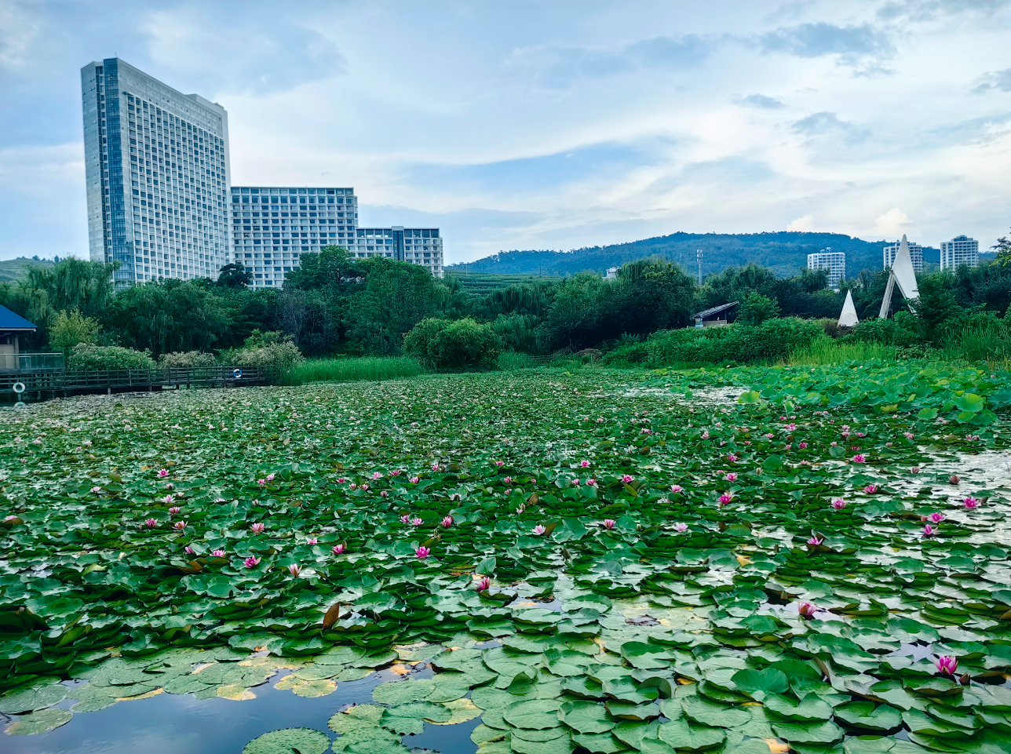 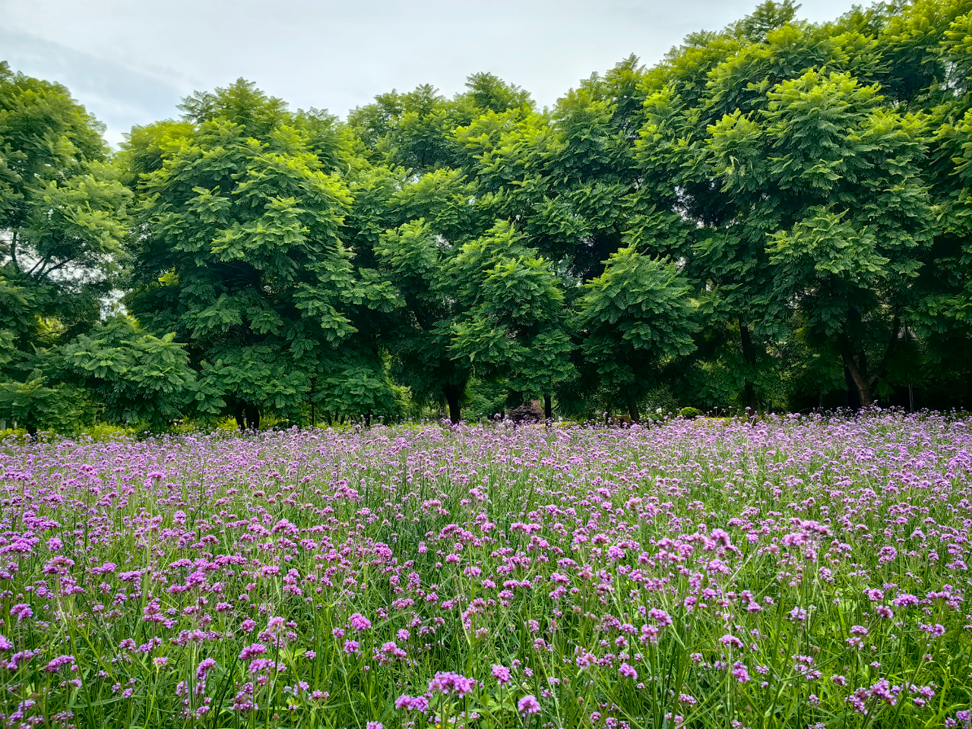

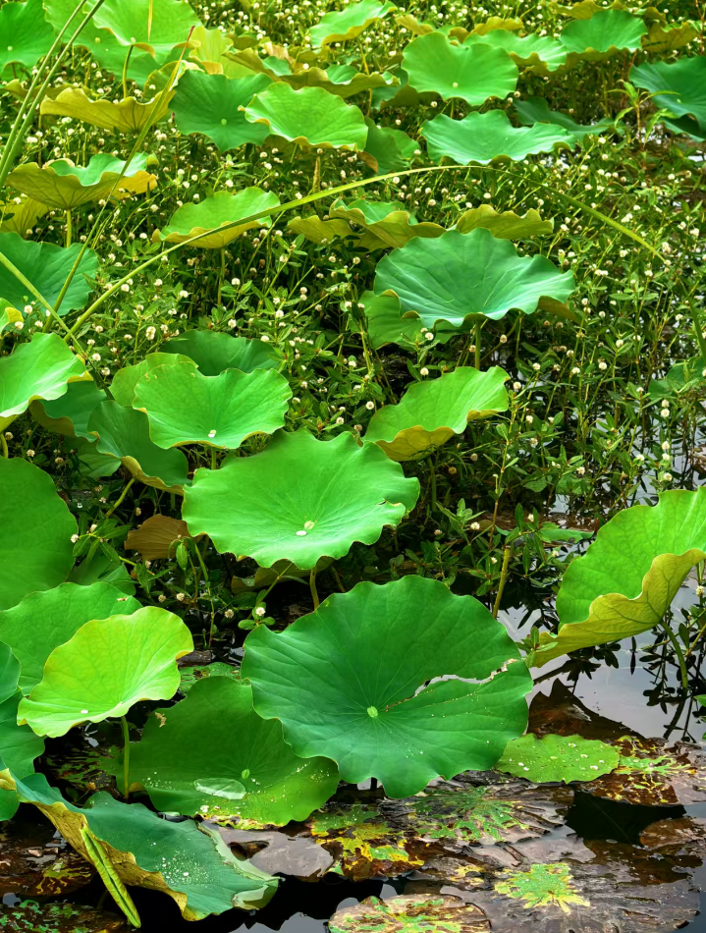  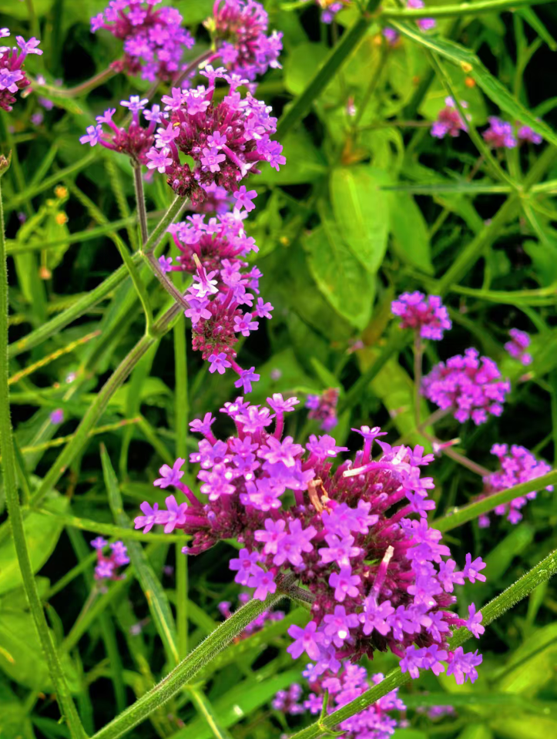

Meet [extraordinary](http://www.baidu.com/link?url=38d3ujRPWPPyoaLR15EnsmADCmHlQEy6zXM39t5e87N3OAMzLH_fGqBiWrMdijLu2ir9rIo8rqa-Eih-j0EbpU5kmuRNclQnlwoTcrPJmyS) beauty of Fuxian Lake by the lakeside, meet the blue paint that has been overturned by nature

 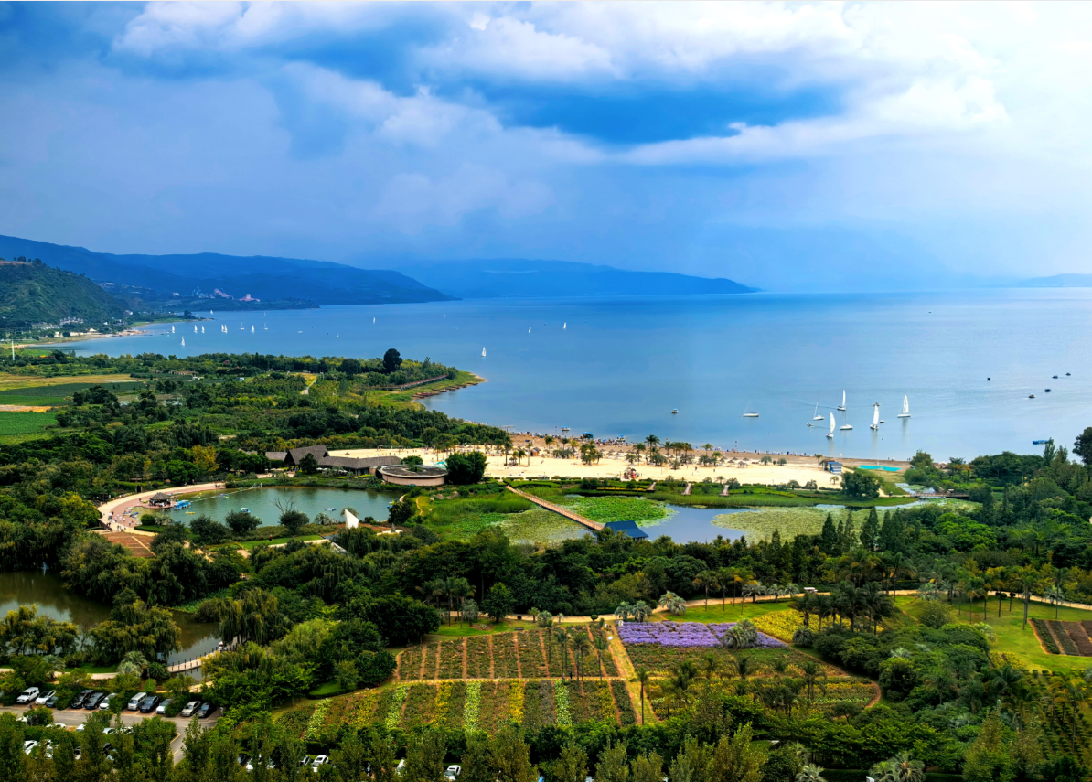

 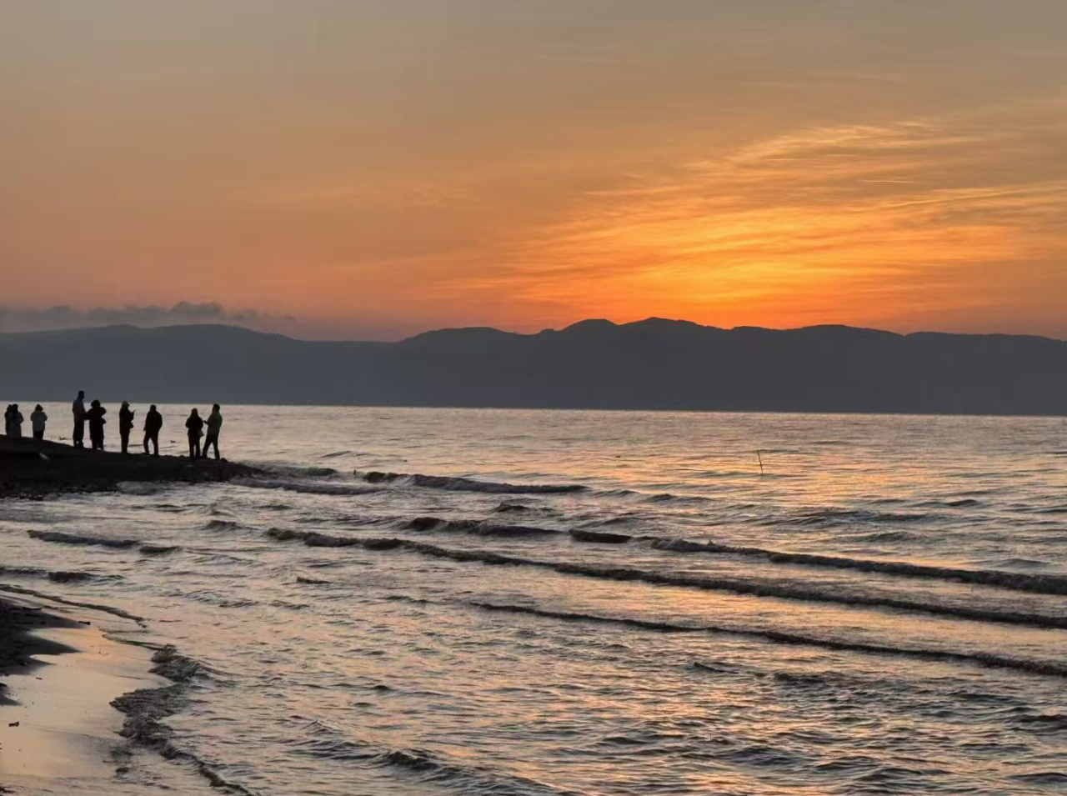

Set sail against the wind, try your favorite water sport

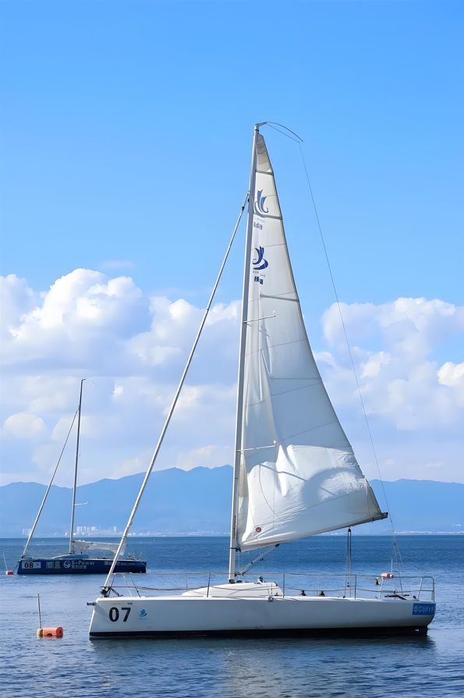  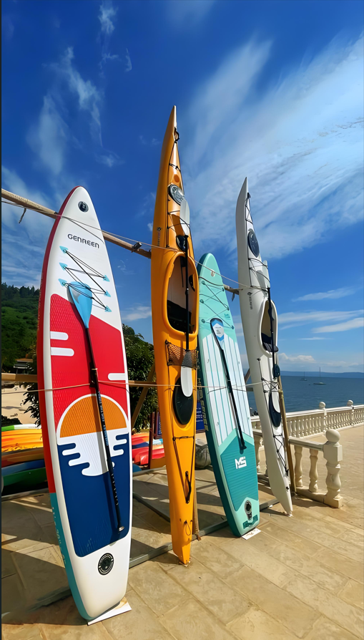

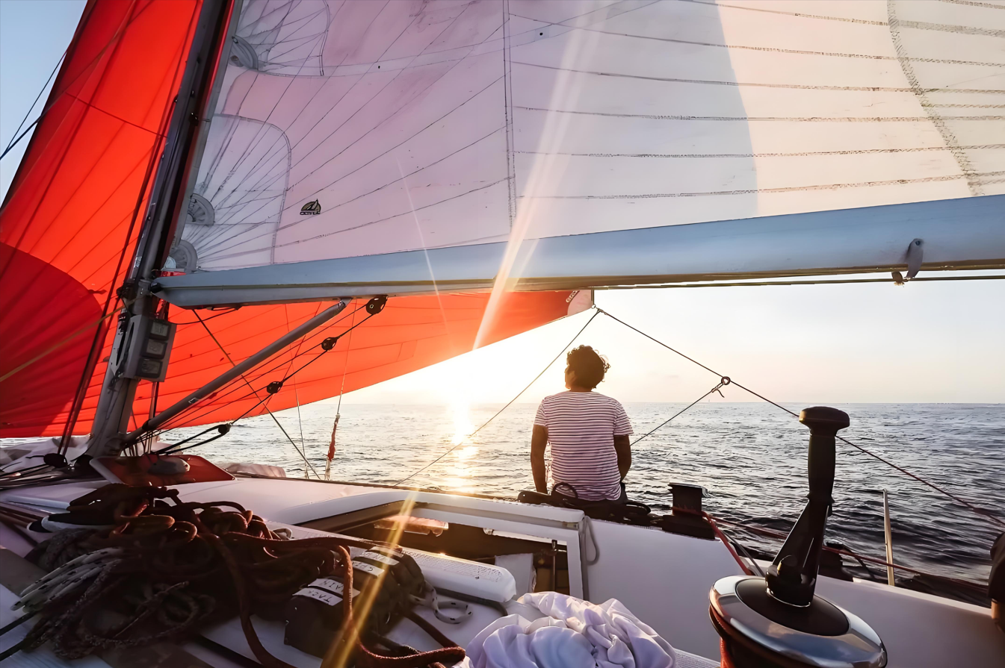

Climb Bijia Mountain nestled beside the lake, enjoy the gentle breeze

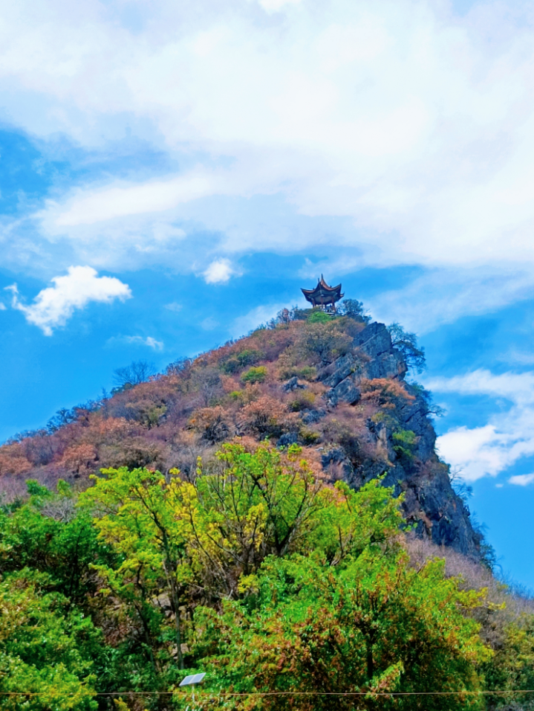 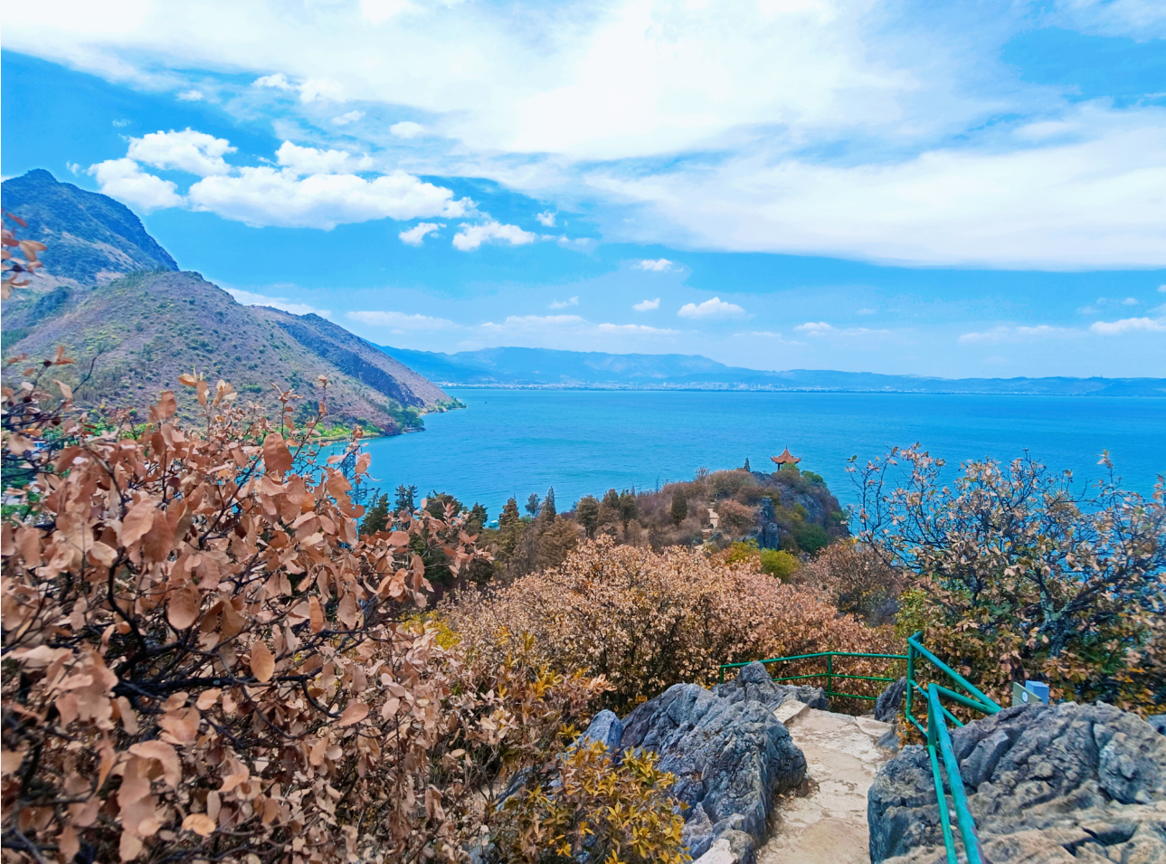

Visit the Yunnan Provincial Museum of Natural History located on the Fuxian Lake fossil site, listen to the grand story of life evolution

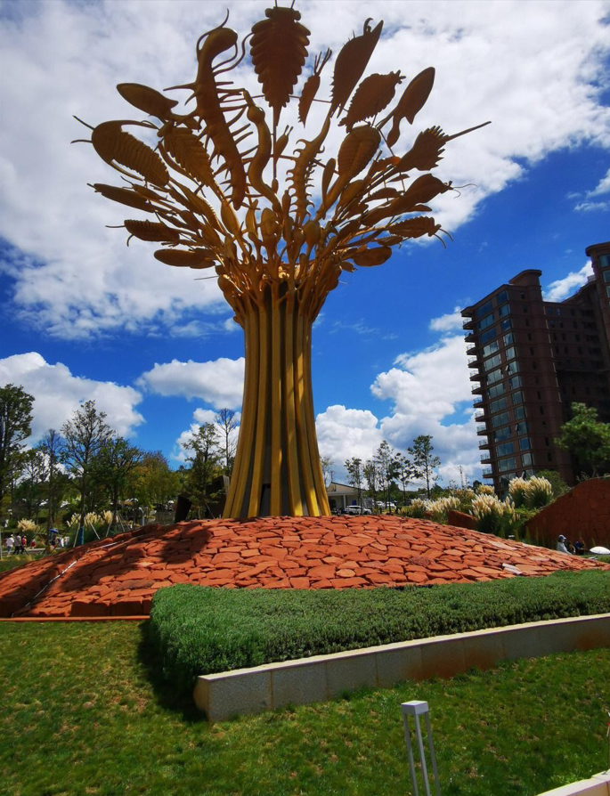 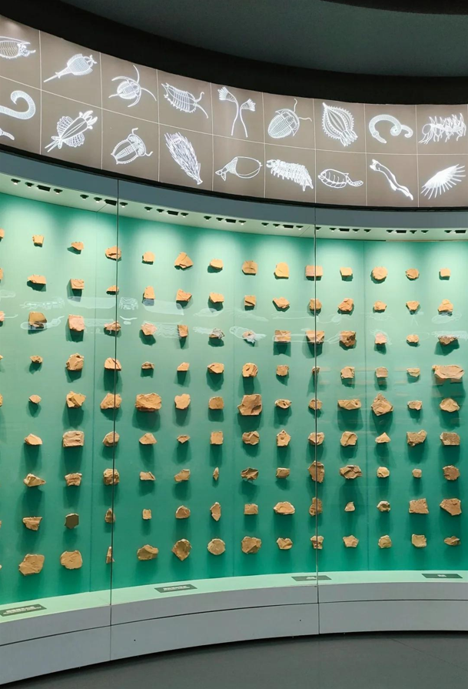

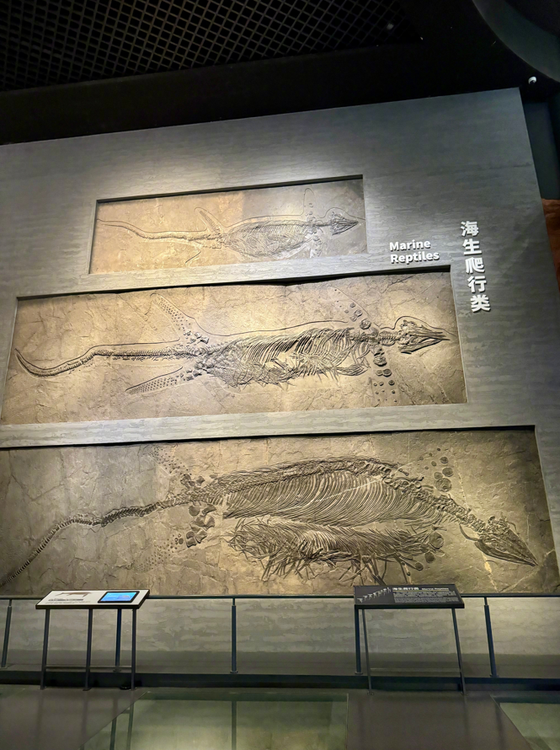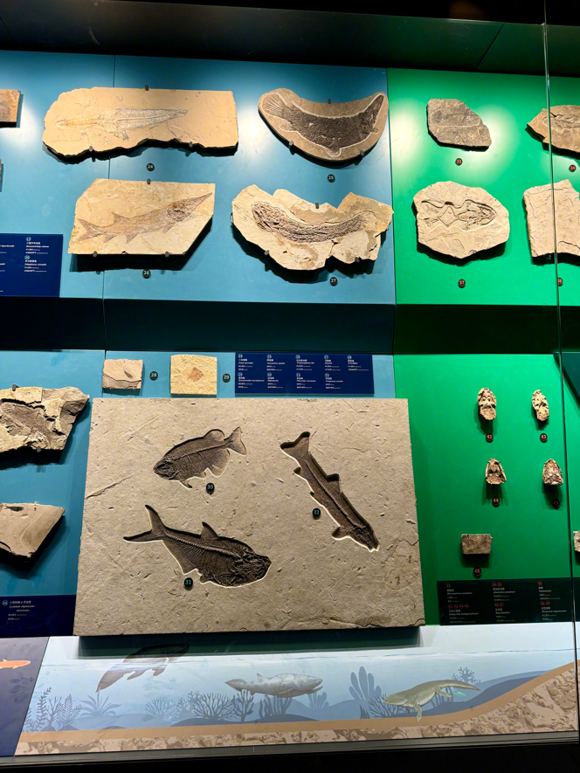

**Excellent tutors**

All tutors in our team have undergone comprehensive **training** and hold **professional** certificates，CTCSOL（Certificates for Teachers of Chinese to Speaker of Other Languages）or Teacher qualification certificate，together with **rich teaching experiences.**

They will provide you with patient, professional and targeted teaching, and solve your problems with a variety of different methods, making the lessons **interesting and practical.**

**（老师和学生一对一上课图片）**

**（这里请增加一个按键链接到导师团队）**

**More info about tutors team**

**Accommodation**

The accommodation for you is very **close to Fuxian Lake.**

Your room is an independent room with a private bathroom, clean, tidy, **safe** and comfortable.

Free room cleaning service is offered **everyday**.

24-hour hot water, WIFI and other necessary living facilities are included.

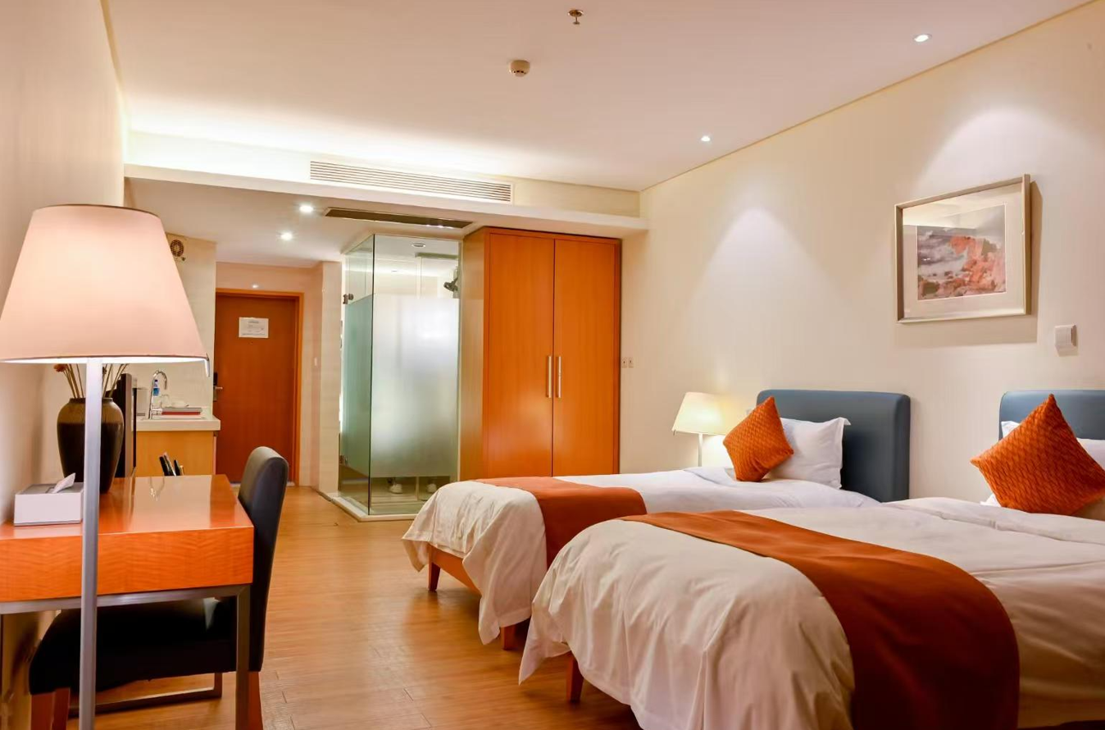 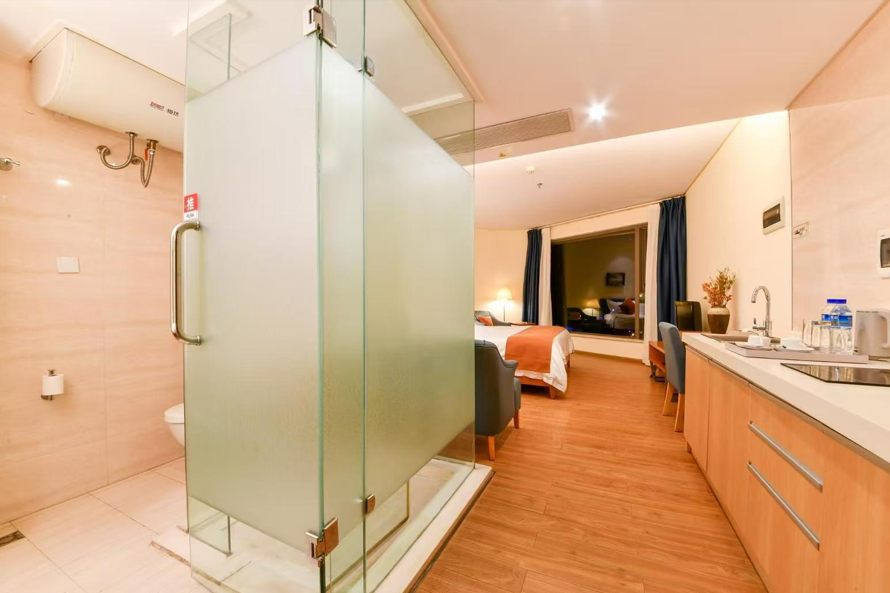

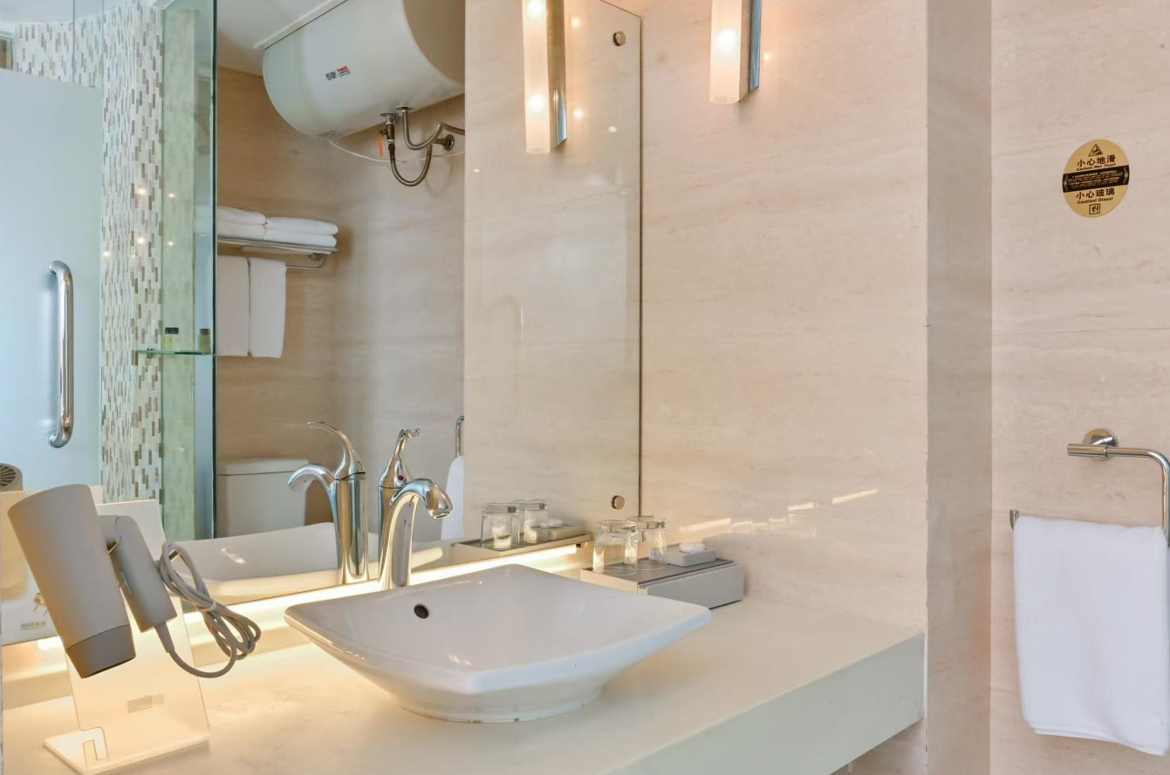 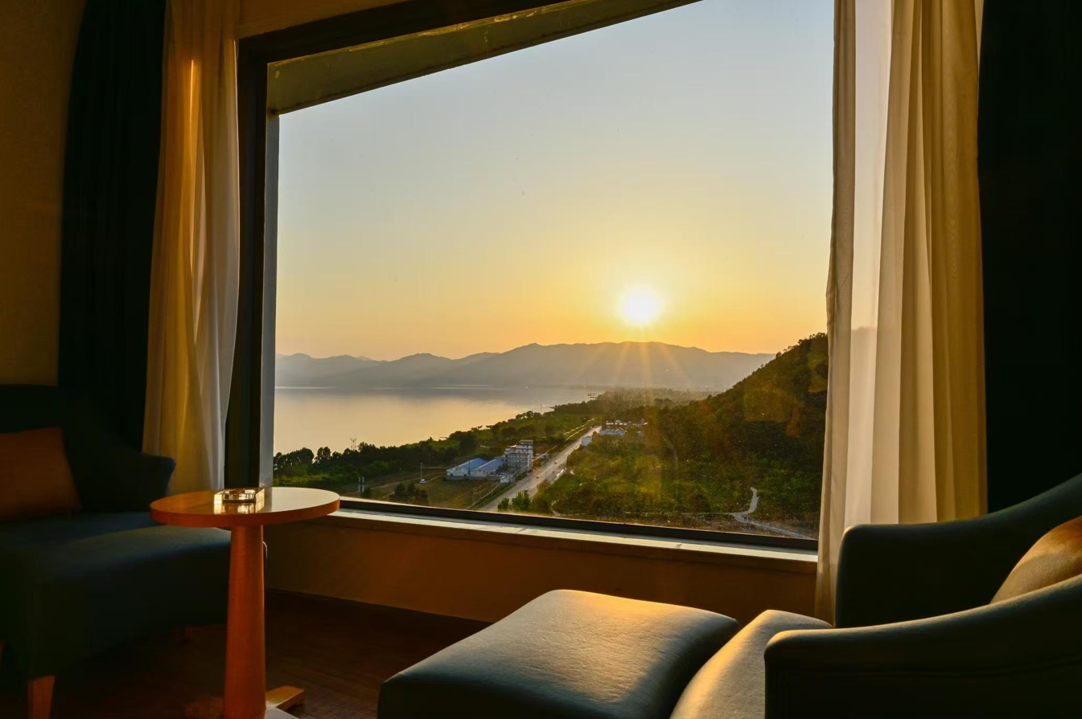

**How to get Fuxian Lake**

Fuxian Lake is located in Yuxi city, 60 kilometers away from provincial capital Kunming, and the

most convenient way to reach Fuxian Lake is by taxi, it will take you about 1.5 hours to get

there.

You can try using Didi to take a taxi and experience the taxi hailing in China, which is very

convenient and fast.



**Pricing**

**Special offer！**

4 hours per day (20 hours a week)

$1300/ week

5 hours per day (25 hours a week)

$1490 / week

6 hours per day (30 hours a week)

$1630/ week

**Ready to launch your Chinese learning journey?**

**Apply now**

The fee includes:

🗹 Personalized Chinese classes per week

🗹 Program certificate

🗹 3 meals Monday to Friday and accommodation

🗹 Kunming airport pick-up and drop-off

🗹 Orientation

🗹 All the campus facilities

🗹 Moon Bay Wetland Park Fees

🗹 Room cleaning everyday

🗹 Free WIFI

🗹 Commonly used medicines

🗹 24/7 support

🗹 Visa support materials